**Beet Seed**

**ID:** B_01

**Environment:** Microsoft Edge v113

**Priority:** Medium

**Summary:**

The “Cacaogold “ group in Viber doesn’t open after clicking on its link in the “Оплата і доставка” in the header menu

**Description**

Steps to reproduce:

1. Open the main page of the website <https://cacaogold.com.ua/uk>
2. Click on “Оплата і доставка “ in the header menu
3. Click on the Viber group link at the top of the page

**Expected result:**

The “Cacaogold “ group in Viber opens after clicking on its link in the “Оплата і доставка in the header menu

**Actual result:**

The “Cacaogold “ group in Viber doesn’t open after clicking on its link in the “Оплата і доставка “in the header menu

**Attachments:**

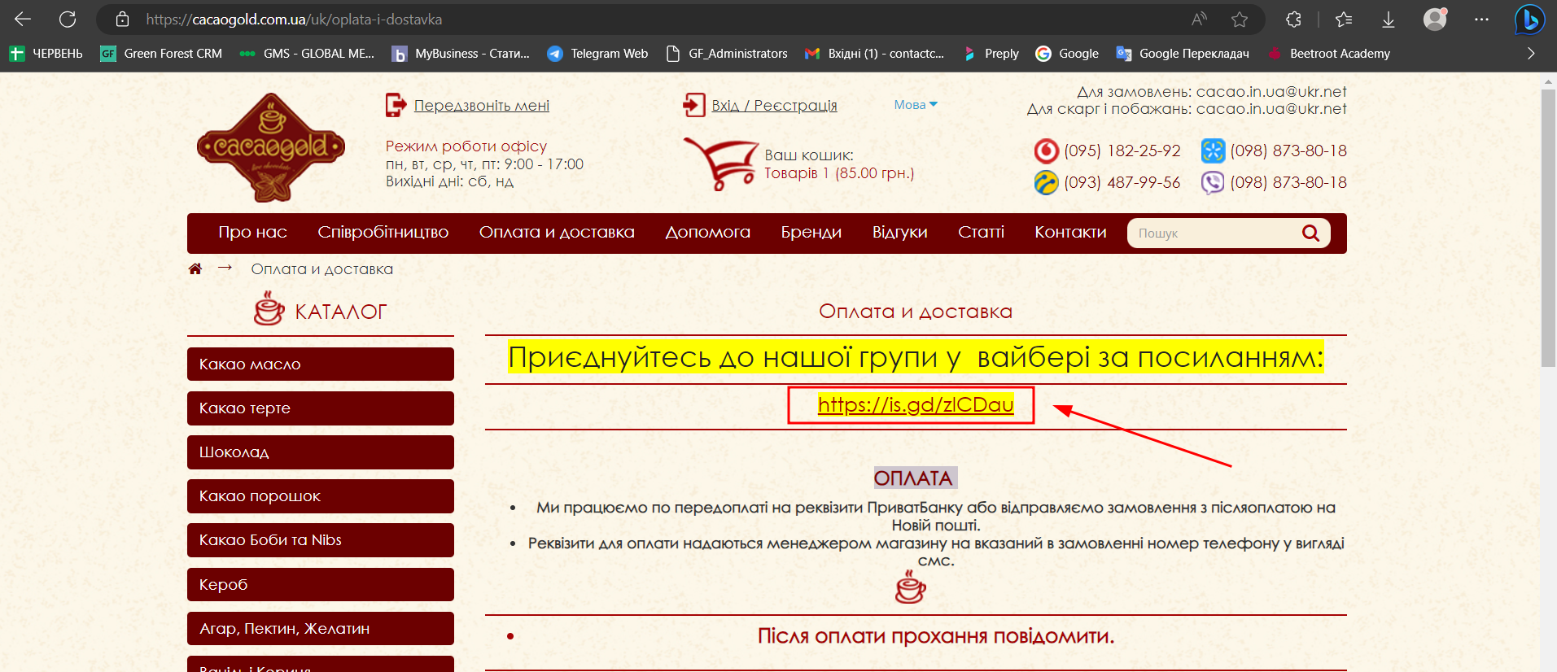

**ID:** B_02

**Environment:** Microsoft Edge v113

**Priority:** High

**Summary:**

The website language automatically changes from Ukrainian language to russian after clicking on "Бренди", "Відгуки", "Статті" in the header menu

**Description**

Steps to reproduce:

1. Open the main page of the website <https://cacaogold.com.ua/uk>
2. Click on "Бренди" in the header menu
3. Select “Мова “ in the language switcher
4. Click on "Відгуки" in the header menu
5. Select “Мова “ in the language switcher
6. Click on "Статті" in the header menu.

**Expected result:**

The website language doesn’t change after clicking on "Бренди", "Відгуки", "Статті" in the header menu

**Actual result:**

The website language automatically changes from Ukrainian language to russian after clicking on "Бренди", "Відгуки", "Статті" in the header menu

**Attachments:**

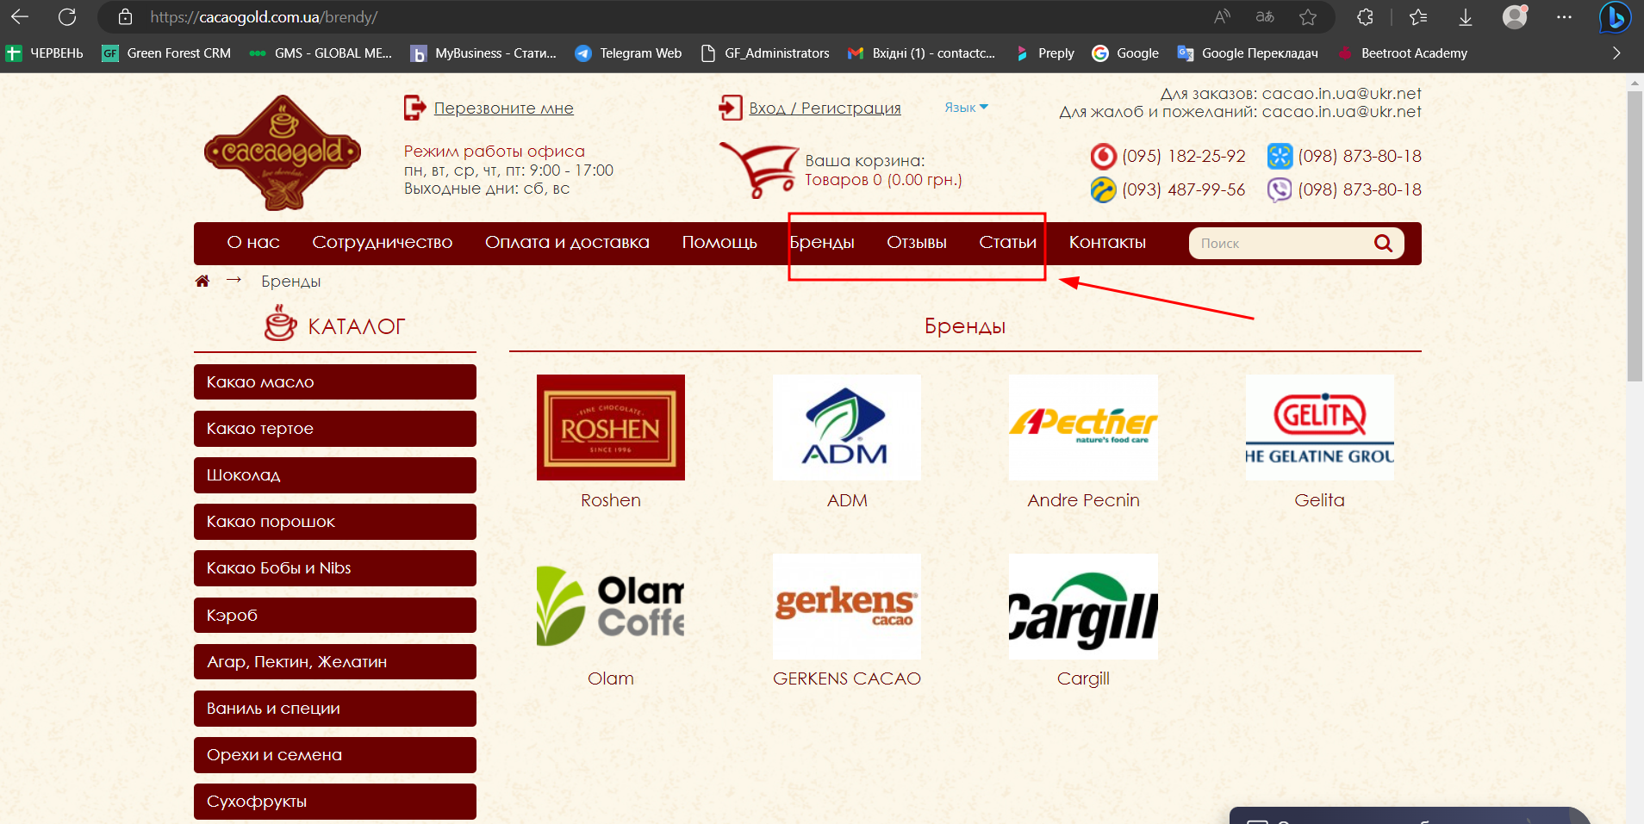

**ID:** B_03

**Environment:** Microsoft Edge v113

**Priority:** Medium

**Summary:**

Information about the work schedule is provided in russian when the Ukrainian language is selected in the “Контакти “ in the header menu

**Description**

Steps to reproduce:

1. Open the main page of the website <https://cacaogold.com.ua/uk>
2. Click on "Контакти" in the header menu
3. Look at the section “Режим роботи “

**Expected result:**

Information about the work schedule is provided in Ukrainian when the Ukrainian language is selected in the “Контакти “ in the header menu

**Actual result:**

Information about the work schedule is provided in russian when the Ukrainian language is selected in the “Контакти “ in the header menu

**Attachments:**

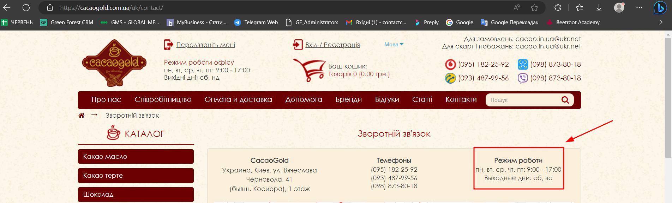

**2.**

**HTML-документ:**

Прикріпила окремим файлом

1. **Підключення стилю всередині тегу (inline) :**



1. **Підключення стилю в розділі “HEAD” :**

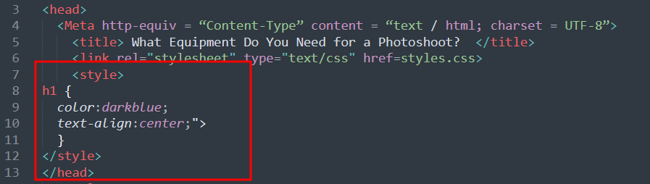

1. **Підключення стилю у зовнішньому .css файлі:**

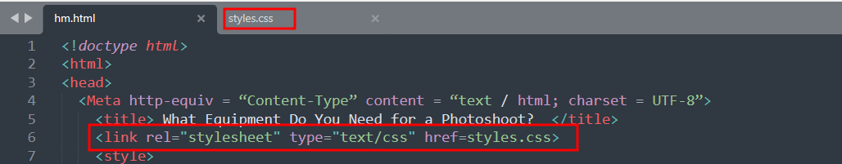

**css файл:**

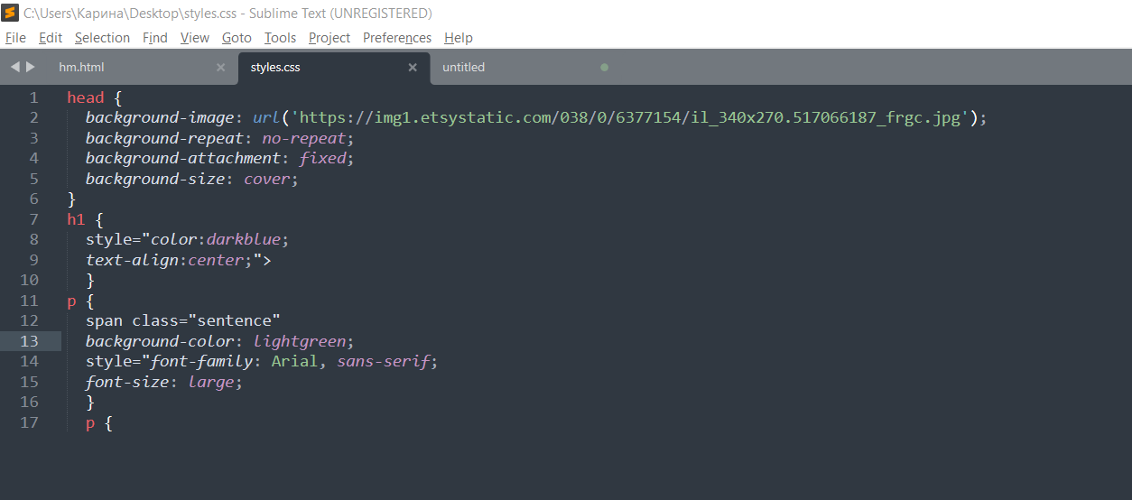

**3.** Для перевірки використовувала два браузери Microsoft Edge та Firefox. Різниця незначна, дещо відрізняється шрифт тексту, майже непомітно :

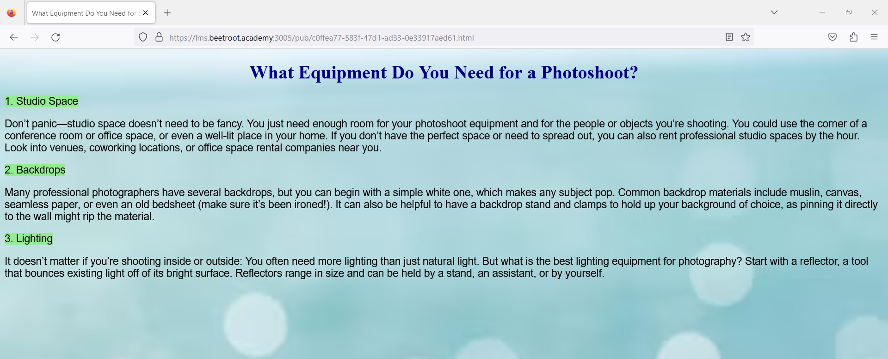

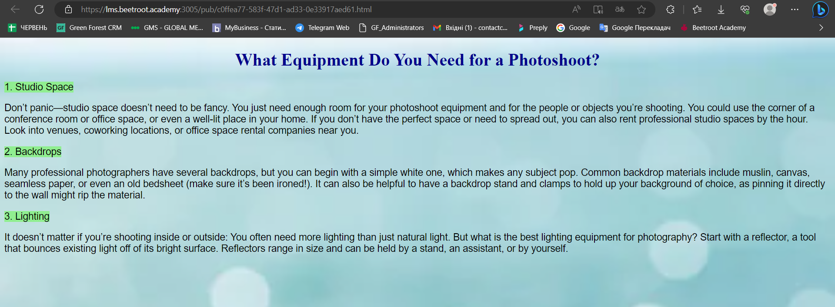

**Mighty Beet**

* [**https://beetroot.academy**](https://beetroot.academy/)- UTF 8
* [**https://microseniors76.com/**](https://microseniors76.com/)- iso-8859-1
* [**https://www.tennis-warehouse.com/**](https://www.tennis-warehouse.com/)- macintosh
* [**https://www.fidelity.com/**](https://www.fidelity.com/) - iso-8859-1